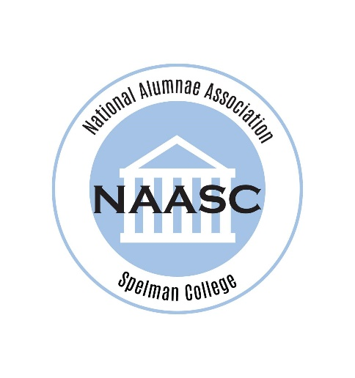
Stacey A. Frazier, C’99 is the National Assistant Corresponding Secretary for NAASC. She has been an active member of the NAASC for over 20 years and is a Life Member. At the local level, she is the current president of the New York chapter, where she has previously served as President-elect and Assistant Corresponding Secretary.
Stacey earned her BA in Economics, with a minor in Management & Organization. A native of the Bronx, after graduating from Spelman, she returned to NYC as a management consultant for Deloitte Consulting. After 9/11, she realized that she wanted to do more to give back to her local community and went to work for NYS Senator Carl Andrews as a Community Liaison. In 2004, she began working for the NYC Department of Education (DOE). While there, she was the Grant Manager for the Reading First program, established and managed the Cost/Price Analysis unit, and served as the Director of Instructional Services Procurement for the Division of Contracts.
In 2010, Stacey received her MBA from the Stephen M. Ross School of Business, with a concentration in Marketing and Corporate Strategy. Post MBA, she spent a year as a Buyer for Target. While she loved the energy and excitement of retail, she realized that her passion was truly in urban education and returned to the DOE in 2011, where she is currently the Deputy Director of Operations for the Division of Human Resources.
Stacey is also a Leadership Coach for the Braven program at Spelman College. Her dedication to the community extends far beyond her hometown of NYC as she has done missionary work in New Orleans, Haiti, and South Africa. She is active in her church and is a self-proclaimed foodie who loves to travel, read, and spend quality time with family and friends.

